Name:_______________________

Chapter 6
Chemical Bonds

Section 1: Ionic Bonds

Lewis Electron-Dot Symbols
The ________ number gives the number of valence electrons.
Place one dot per valence electron on each of the four sides of
the element symbol.
Pair the dots (electrons) until all of the valence electrons are
used.
Example:
Nitrogen (N) is in Group 5A and therefore has 5 valence electrons.
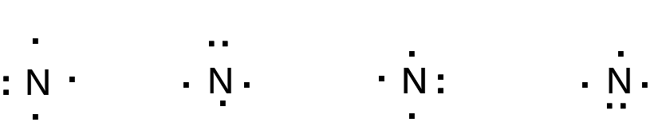

General Rules:
- For a metal, the total number of dots equals the maximum
number of ____________ it loses to form a ___________.
- For a non-metal, the number of unpaired dots equals the
number of ___________ that become paired either through electron gain or electron sharing. The number of unpaired dots equals either the negative charge of the __________ an atom forms or the number of covalent bonds it forms.

Lewis electron-dot symbols for elements in Periods 2 and 3
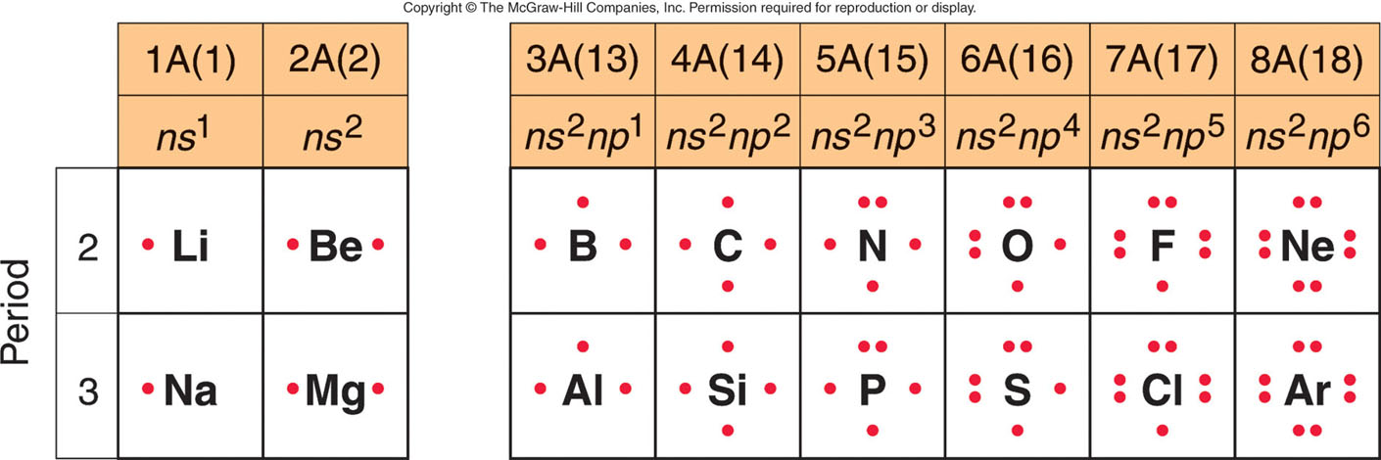

The Ionic Bonding Model
- Involves the ______ of electrons from metal to non-metal to form
ions that come together in a solid ionic compound
- The Octet Rule
- When atoms bond, they lose, gain or share electrons to attain a
_______ outer shell of ____________ _____ electrons
-In ionic bonding, the total number of electrons lost by the ______
atoms equals the total number of electrons gained by the ____________ atoms.

IONS
In order to understand what ions are, we need to know that…
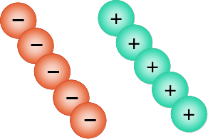
the particles
that make up atoms
have either
positive or negative charge

positive and negative are opposites, they cancel each other out

net charge = zero

in an atom, protons ( + ) are in the center and electrons ( ) are on the outside
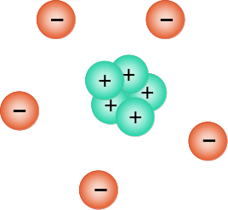


only electrons ( - ) can be added or taken away

this is an atom with 5 electrons and 5 protons
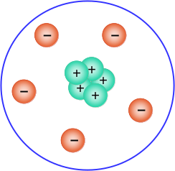

the atom is neutral -- net charge = zero
5 (-) and 5 (+) = zero charge (neutral)
WHEN REMOVING ELECTRONS
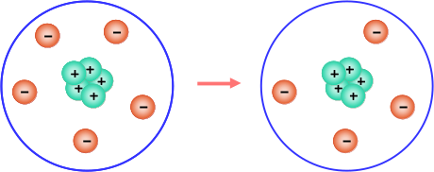

THE RESULTING CHARGE IS ____________
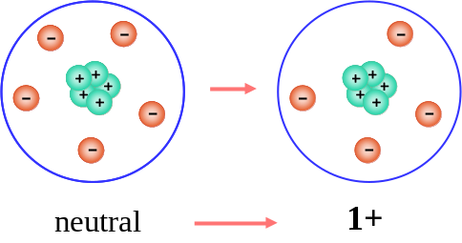

______________
WHEN ADDING ELECTRONS

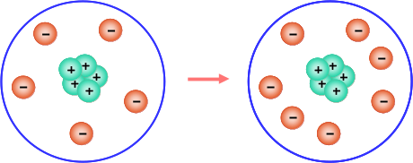

THE RESULTING CHARGE IS _____________
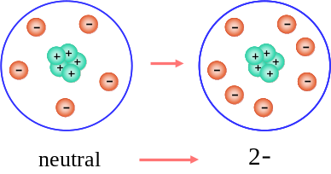

________________

An atom with positive or negative charge is called an __________.

Atoms without charge are called _________
Atoms with positive or negative charge are called __________

Notice that ONLY the number of ___________ changes
(Only ___________ are added or subtracted)
The number of ___________ in an Atom NEVER changes

Ionic Compounds
Ionic Bonds
What is an Ionic Bond?
- An Ionic Bond is a chemical bond resulting from the
_____________ of electrons from one bonding atom to
another
When is an ionic bond formed?
- An ionic bond is formed when a _________ (positive ion)
transfers electrons to an ___________ (negative ion).

Ionic Compounds
- Consist of __________ and ___________ ions.
- Have attractions called ___________ _______ between positively and negatively charged ions.
- Have high ___________ and ____________ points.
- Are __________ at room temperature.

Salt is An Ionic Compound
Sodium chloride or “table salt” is an example of an ionic compound.
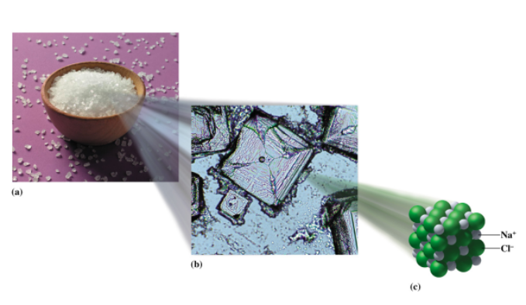

Ionic Formulas
An ionic formula
- Consists of positively and negatively charged _______.
- Is ___________.
- Has charge _____________.
total positive charge _____ total negative charge
- The symbol of the _________ is written __________ followed by the symbol of the nonmetal.
Charge Balance for NaCl, “Salt”
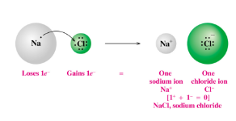
In NaCl
- A Na atom ____ its valence electron.
- A Cl atom ________ an electron.
- The symbol of the _________ is written first followed by the symbol of the nonmetal.

Charge Balance In MgCl₂
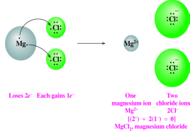
In MgCl₂
- A Mg atom loses ___ valence electrons.
- Two Cl atoms each gain ____ electron.
- Subscripts indicate the number of ions needed to give charge balance.

Guide to Writing Electron-Dot Formulas
STEP 1 Determine the arrangement of atoms.
STEP 2 Determine the total number of valence electrons.
STEP 3 Attach each bonded atom to the central atom
with a pair of electrons.
STEP 4 Place remaining electrons as lone pairs to
complete octets (2 for H atoms).
STEP 5 If octets are not complete, form a multiple bond
by converting a lone pair to a bonding pair.
Writing Ionic Formulas from Charges
Charge balance is used to write the formula for
sodium nitride, a compound containing Na⁺ and N³⁻.
Na+
3 Na+ + N3− = Na₃N
Na+

3(+1) + 1(3-) = 0

Learning Check
Select the correct formula for each of the following ionic
compounds and draw a Lewis Dot Diagram for each answer.

A. Na⁺ and S²⁻
1) NaS 2) Na₂S 3) NaS₂

B. Al³⁺ and Cl⁻
1) AlCl₃ 2) AlCl 3) Al₃Cl

C. Mg²⁺ and N³⁻
1) MgN 2) Mg₂N₃ 3) Mg₃N₂

Section 2

Covalent Bonding

Covalent bonds form
- When atoms ________ _________ to complete octets.
- Between two _____________ atoms.
- Between ____________ atoms from Groups 4A(14), 5A(15), 6A(16), and 7A(17).

Hydrogen Molecule (H2)
In a hydrogen molecule (H2), each H atom
- Shares electrons to form a covalent ________ bond.
- Acquires _______ electrons.
- Becomes stable like __________
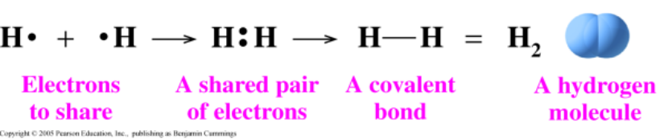

Forming Octets in Molecules
In a fluorine F₂ molecule, each F atom
- Shares _____ electron.
- Acquires an _______.
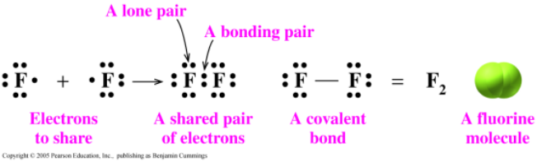

Diatomic Elements
These elements _______ electrons to form diatomic, covalent molecules.
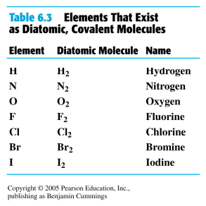
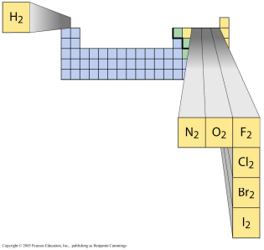

Carbon forms 4 covalent bonds

In a CH₄, methane, molecule
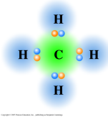
- The central C atom shares ___
electrons to attain an octet.
- Each H atom shares ___ electron
with the carbon atom to become stable like He.

Electron-Dot Formula for NH₃
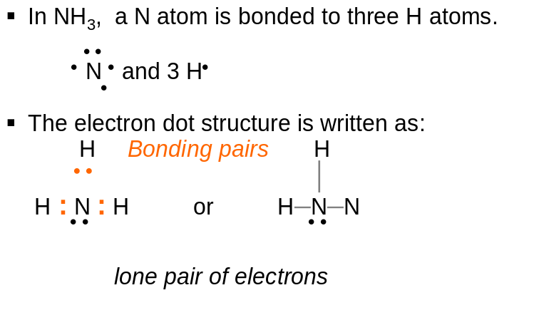

Single and Multiple Bonds
In a single bond
- __________ pair of electrons is __________.

In a double bond,
- __________ pairs of electrons are _________.

In a triple bond.
- __________ pairs of electrons are __________.

Electron-Dot Formula of CS₂
Write the electron-dot formula for CS₂.

STEP 1 Determine the atom arrangement.
The C atom is the central atom.
S C S

STEP 2 Determine the total number of valence
electrons for 1C and 2S.
1C(4e-) + 2S(6e-) = 16e-
STEP 3 Attach each S atom to the central C atom using one
electron pair.

S : C : S
16e- - 4 e- = 12e- left

STEP 4 Attach 12 remaining electrons as 6 lone pairs to
complete octets.
.. ..
: S : C : S :
.. ..
STEP 5 To complete octets, form one or more multiple bonds.
Convert two lone pairs to bonding pairs between C and S
atoms to make two double bonds.
.. .. .. ..
: S : : C : : S : or : S = C = S :

A Nitrogen Molecule has A Triple Bond
In a nitrogen molecule, N₂,
- Each N atom shares ___ electrons.
- Each N atom attains an ________
- The sharing of ___ sets of electrons is a multiple bond called a ______ bond.
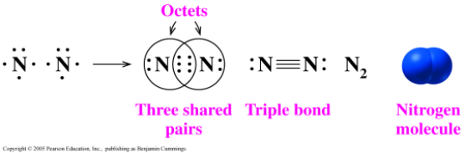

Covalent Compounds
- Weak forces __________ molecules, not the strong covalent bonds _________ each molecule, are responsible for the physical properties of covalent compounds.
- Covalent compounds have relatively _________ melting and boiling points.
- Most covalent compounds are _______ electrical conductors.
- Strong forces within molecules, weak forces between them

________ covalent bonding forces within molecules
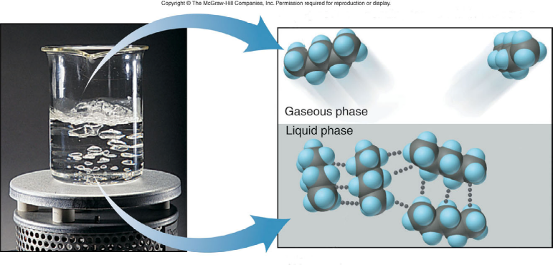

_________ intermolecular forces between molecules

Polar Covalent

Polar covalent is a description of a
bond that has an __________ distribution
of charge due to an _______ sharing of bonding
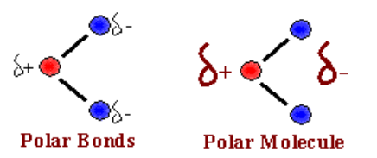

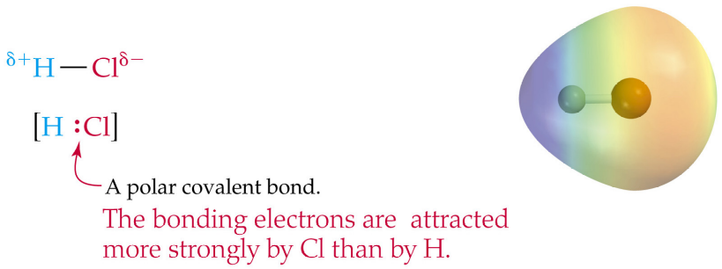

Non-Polar Covalent
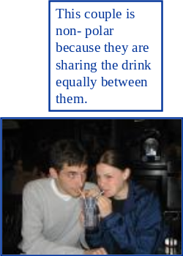

Non polar covalent is a covalent
bond that has an ______ distribution
of charge due to an ________ sharing
of bonding electrons.
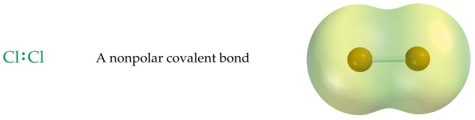

Just as a summary to what each bond looks like…


